8.3.5 Editors - Image Editor - Sidebar - Mask Tab
Introduction 1
Mask Settings Panel 2
Start Frame 2
End Frame 2
Mask Layers Panel 2
Mask Layer List 2
Restrict View 2
Restrict Select 2
Restrict Render 2
Drag Handler 2
Search Field 3
Invert 3
Sort by Name 3
Revert 3
Add Mask Layer 3
Last Operator Add Mask Layer 3
Name 3
Remove Mask Layer 3
Move Layer 3
Opacity 3
Invert 3
Blend 3
Falloff 4
Overlap 4
Holes 4
Mask Layers Panel 4
Feather Offset 4
Interpolation 4
Cyclic 4
Fill 4
Self Intersection Check 4
Active Point Panel 5
Parent 5
Parent Type 5
Object 5
Track 5

Introduction

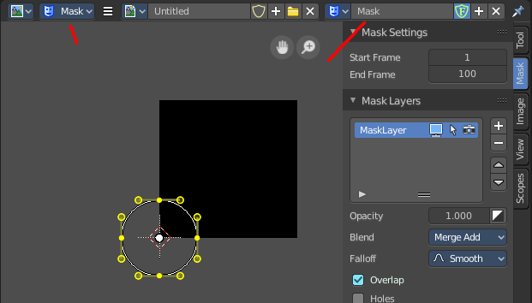
The mask tab just shows in Mask mode and with an existing mask.

It contains tools and settings for the mask mode. Like a layer system.

Mask Settings Panel

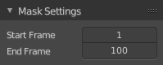
This values are of interest for the Sequencer, where you work with movies and image sequences.

Start Frame
Set the first Frame of the mask.

End Frame
Set the last Frame of the mask.

Mask Layers Panel

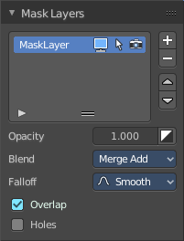
When you add a spline, a circle or a square or a freehand one, then a Mask Layer gets created.

You can create several mask layers and work with them in the sequencer or the Node editors. They can be used to create complex shapes, and define how the splines interact with each other. Splines at the same layer can be animated together.

Splines can be copied and pasted from one layer to another.

Mask Layer List
The list of available mask layers.

Restrict View
Don't show this mask layer in the viewport.

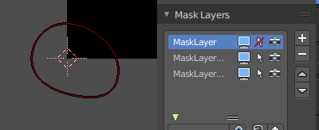
Restrict Select
Selection in the viewport is enabled or disabled. The spline handlers becomes invisible.

Restrict Render
Don't render this mask layer for the final image(s).

Drag Handler
The two vertical lines at the end is a handler with which you can expand the list.

Search Field
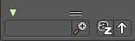
You can expand a search field at the bottom of the list. Type in your term and hit enter to filter for your term.

Invert
Exclude the search term instead of searching for it.

Sort by Name
Sort the List by name.

Revert
Revert the list. The last list item beomes the first, and vice versa.

Add Mask Layer
Add a new mask layer to the list.

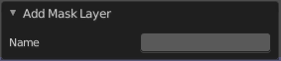
Last Operator Add Mask Layer

Name
Rename the new created mask layer.
Note that you can also rename it in the list.

Remove Mask Layer
Remove the currently selected mask layer from the list.

Move Layer
Move the selected layer up or downwards in the list.

Opacity
Set the opacity of the mask layer.

Invert
Inverts the values (colors) in the mask layer.

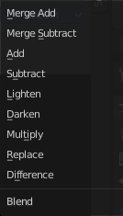
Blend
Adjust the layer blending.

Note, Merge add and Merge subtract should be used with a Feather on overlapping masks to get a better result.

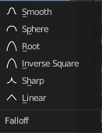
Falloff
Adjust the Feather falloff

Overlap
Fill self-intersecting areas.

Holes
Overlapping splines from the same layer will generate holes in the mask.

Mask Layers Panel
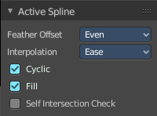
When there is a spline in the current mask layer, then the Active Spline Panel shows. Adjust some settings for the currently active spline.

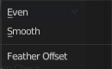
Feather Offset
The method to calculate the feather offset.

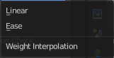
Interpolation
The weight interpolation method.

Cyclic
Make the spline closed or open.

Fill
Fill the spline.

Self Intersection Check
Prevent feather from self intersecting.

Active Point Panel

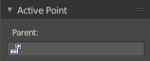
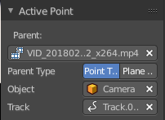
When you select a point of one of the splines, then the Active Point Panel will show up.

This panel is of interest for motion tracking. Control Points can be parented to motion tracks. And this allows to mask out parts of the motion tracked footage.

The masking happens at the Viewer Node.

Parent
Choose the motion track that you want to parent the control point to.

Parent Type
Choose between the methods Point Track or Plane Track.

Object
The parent object. Usually the camera where you track from.

Track
Choose the tracking point that you want to follow with the mask.

